**Statement of Work**

# **for**

## **Color Detection**

By: - Parth Shah (100799064)

Guided by: - Prof. Marcos Bittencourt

Subject: - 1002 – 02 AI Algorithms

**Index**

|  |  |  |
| --- | --- | --- |
| **Sr.no.** | **Title** | **No.** |
| 1 | Summary | 3 |
| 2 | Model | 3 |
| 3 | Data | 3 |
| 4 | Requirement | 4 |
| 5 | Plan | 5 |
| 6 | References | 6 |

1. **Summary**

Identify vivid colors can sometimes become difficult for humans and to over come this and differentiate colors with minute difference only computer system can do it but not humans with normal eyes. Here computer sensors work to identify the colors and generate results from the data present in the database. For this we have total 865 different colors in the database which helps to get the results accurate these colors are made making combination from RGB colors. This AI method helps to create new colors also.

This AI method can be implemented in applications where we can use app to form operations where we can identify color of particular objects and also on other hand can also make own colors and identify which is that color. This app can be used to form new combinations where it can be used to see how it actually looks on particular objects. So, then the app will find the shortest difference from the color in the database and will generate result.

For this OpenCV and Pandas are used as python library. Then first directly image path will be given from using argparse library. Then we need csv files will be used and uploaded as database in pandas. Then the value will be detected and calculation will be done from this which will make the result and from assumption the formula will be used to generate the output or result. The formula can have color combination.

1. **Model**

There are many different possible **models** like

* RGB,
* HSV,
* HLS,
* HIS and
* NCC

For this **RGB model** will be used where there will be cube formation

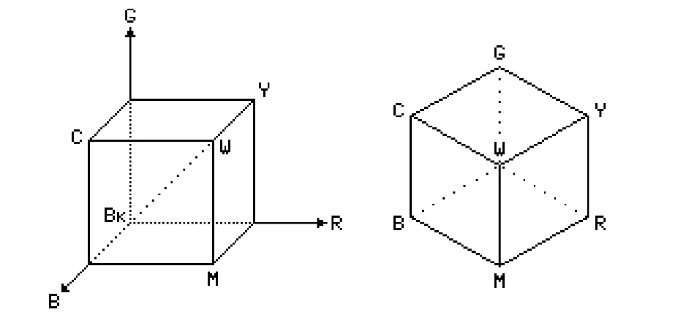

* Dotted line of cube which is diagonal having same amount of RGB (Red, Green and Blue) colors are forming gray color.
* RGB color model is considered as hardware model which is also used in many methods like image capturing, processing and rendering devices.

Camera many times can even fail due to lighting conditions so that is important to take care for the proper results as all the colors needs to be properly reflected in camera lens so then only it can have accurate results. This is also possible with human if human eyes try to identify the color in dark area or environment.

1. **Data Requirements**

* Color data set where all different colors are there with their property.
* It can be in any form but RGB is preferred format.

1. **Data**

* Github: - https://github.com/codebrainz/color-names/blob/master/output/colors.csv
* Data.world: - <https://data.world/datasets/color>
* Color Science: - <https://www.colour-science.org/colour-datasets/>
* Color Constancy: - <https://colorconstancy.com/evaluation/datasets/>

1. **Plan**

|  |  |  |
| --- | --- | --- |
| **Task** | **Perform by** | **When (dd/mm/yy)** |
| Collecting Data | Parth Shah | 03/11/20 |
| Analyzing Data | Parth Shah | 05/11/20 |
| Cleaning Data | Parth Shah | 07/11/20 |
| Making Algorithms | Parth Shah | 10/11/20 |
| Making models | Parth Shah | 15/11/20 |
| Training model | Parth Shah | 25/11/20 |
| Developing Report | Parth Shah | 27/11/20 |
| Developing Scoreboard | Parth Shah | 29/11/20 |
| Developing DashBoard | Parth Shah | 30/11/20 |

1. **References**

<https://github.com/codebrainz/color-names/blob/master/output/colors.csv>

<https://towardsdatascience.com/color-identification-in-images-machine-learning-application-b26e770c4c71>

<https://data-flair.training/blogs/project-in-python-colour-detection/>

<https://www.researchgate.net/publication/259821006_Color_recognition_algorithm_using_a_neural_network_model_in_determining_the_ripeness_of_a_Banana>

<https://www.kdnuggets.com/2020/03/20-machine-learning-datasets-project-ideas.html>

<https://www.cs.ubc.ca/grads/resources/thesis/Nov99/Vladimir-Kravtchenko.pdf>

<https://data-flair.training/blogs/opencv-python-tutorial/>

<https://www2.cs.sfu.ca/~colour/publications/CRA-2002/index.html>